**Permit System with Isolation**

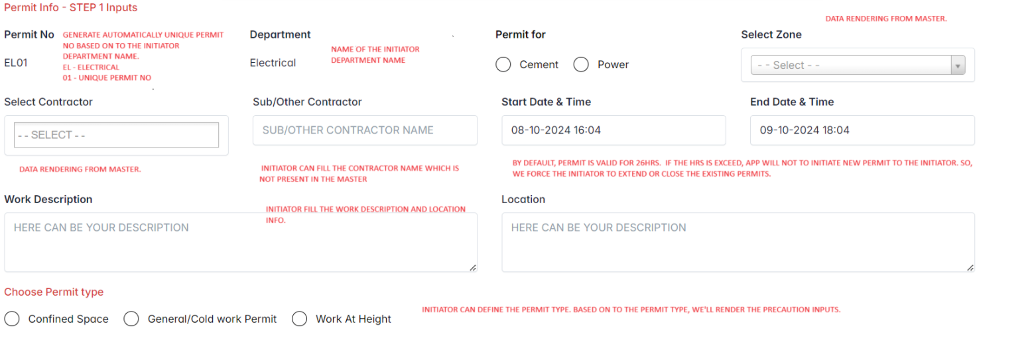

**Confined Space Precautions**

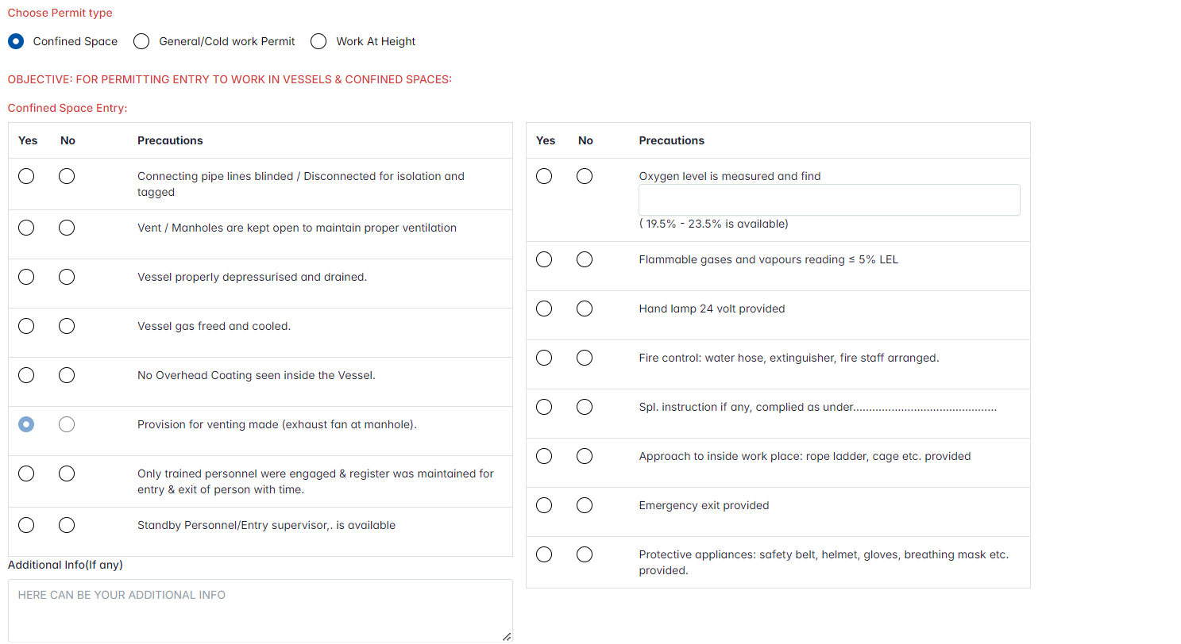

**General work precautions**

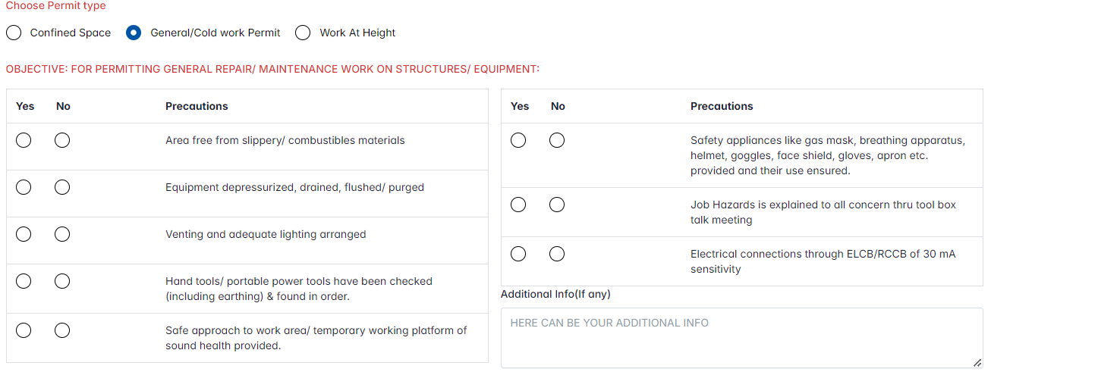

**Work at height precautions**

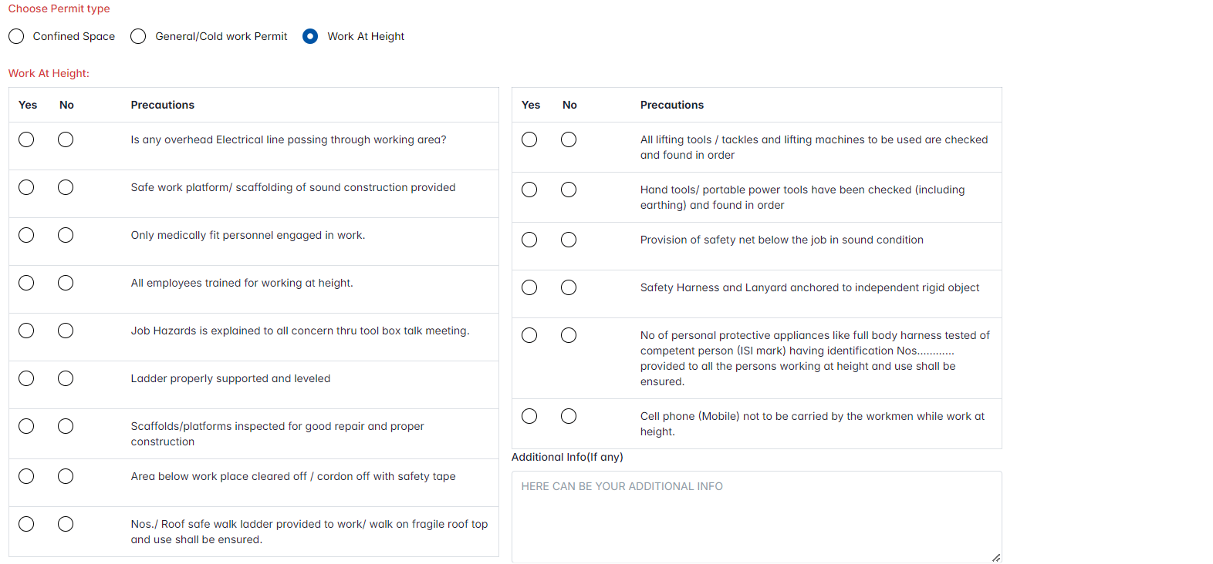

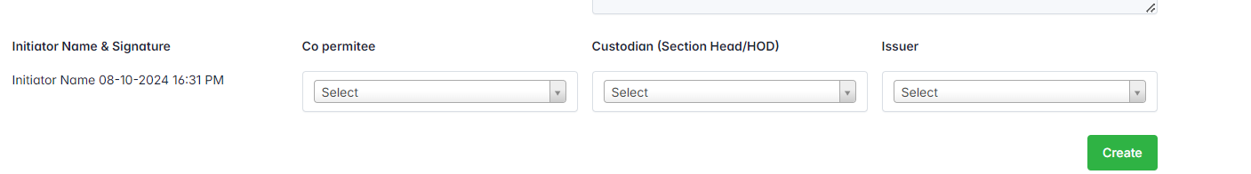

Initiator will choose the Co-permittee & custodians & Issuer from the dropdowns. Once, the initiator hit the “Create” button, new permit will be created and send notification to the custodian.



If the permit not require isolations, once the step 2 is completed by the custodian. We’ll show that permit in dashboard listing.

**STEP 2**

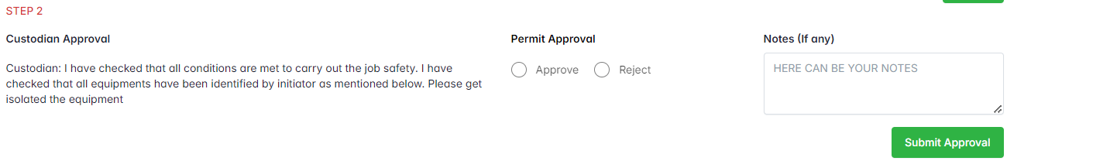

The custodian will review the Step 1 and correct if anything wrong and then give approval/reject the permit. If the reject the permit, the permit will be close automatically otherwise send approval notification to CCR.

**Extend the permit**

**Currently, we’re allowing the initiator to extend the permit next 6days.**

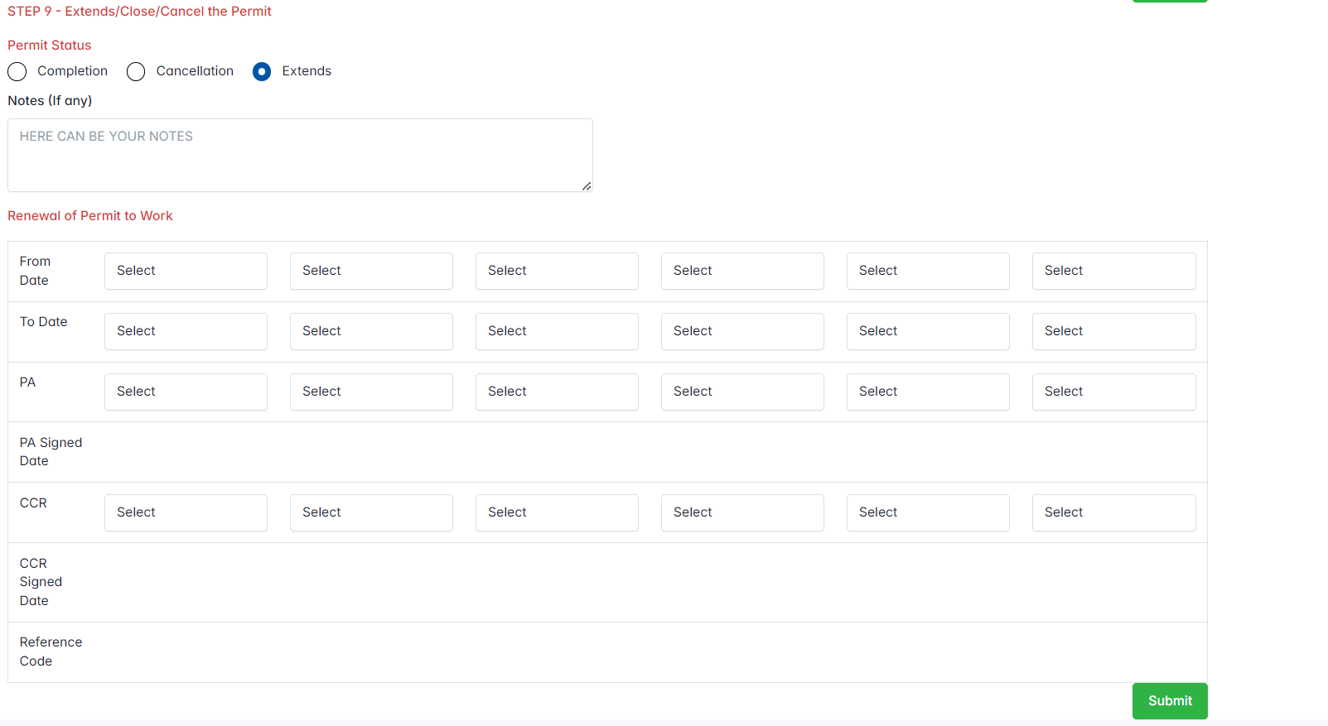

From Date – Current Date

To – Current/Next date

PA(Initiator) – Who is next responsible person to continue the permit work

CCR – Name of the CCR person to approve the permit extends

Ref Code - Using the reference code the issuer will allow to work the permit in outside of the application.

**Closing the permit without isolations**

